Phoenix Windows Application – CAD

**Prerequest**:

* Eclipse
* Selenium
* Java
* WinAppDriver
* WinAppDriverUIRecorder

Phoenix Windows Application framework development documents.

1. Enable Developer Mode option in Windows 10

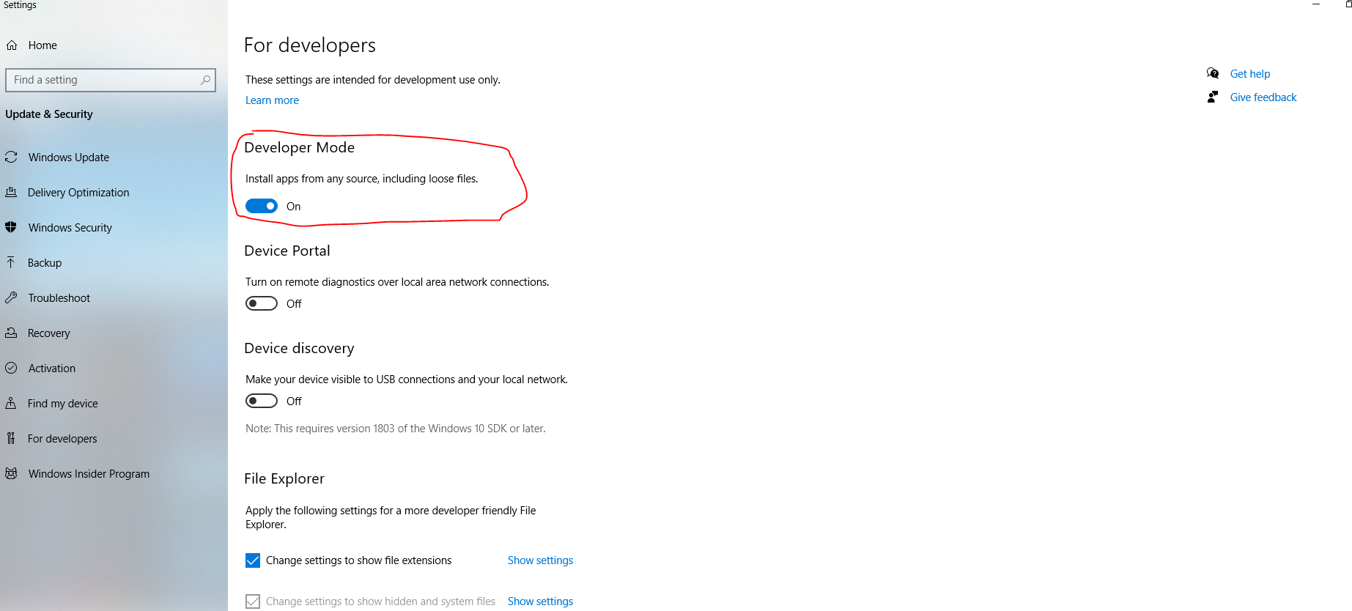

1. **Download WinAppDriver**

url : <https://github.com/microsoft/WinAppDriver/releases/tag/v1.2.1>

Download WinAppDriver in specified path.

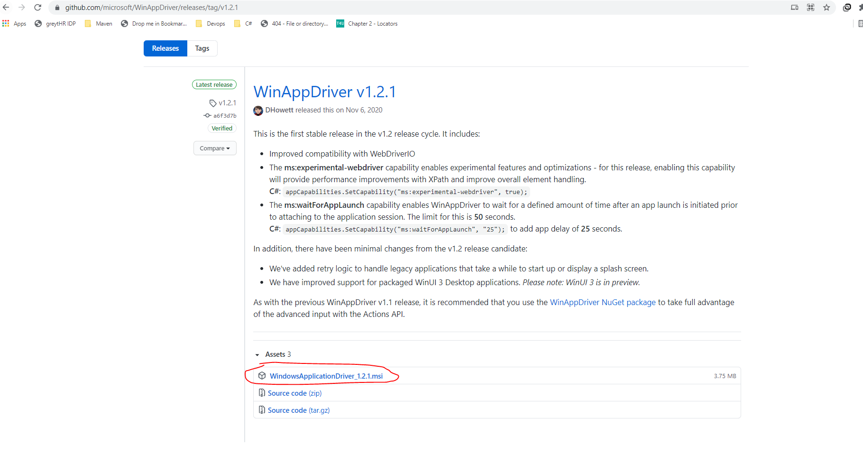

After download WinAppDriver MSI file we want to install driver in local machine

Double click MSI file

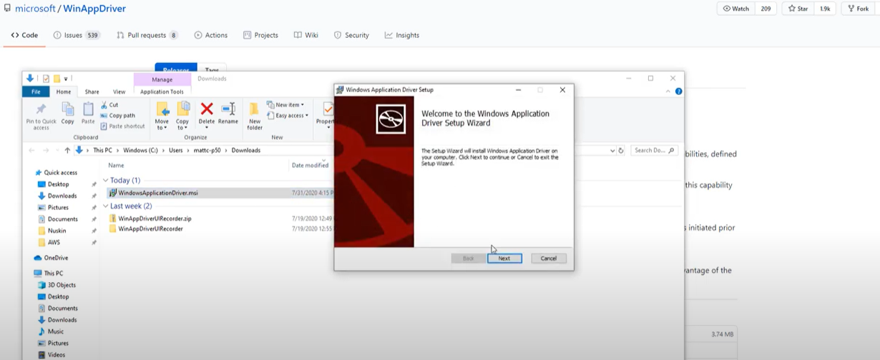

Click on License Agreement Checkbox

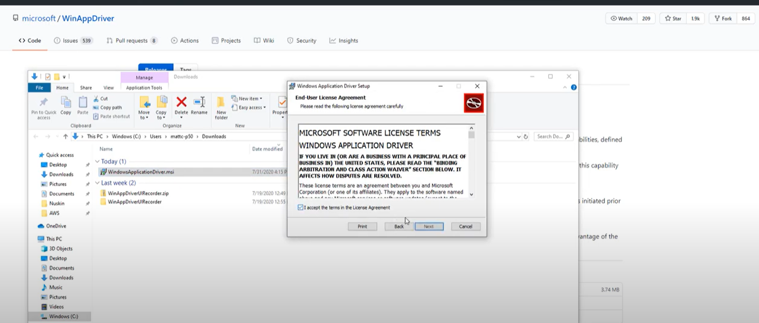

Select File Location

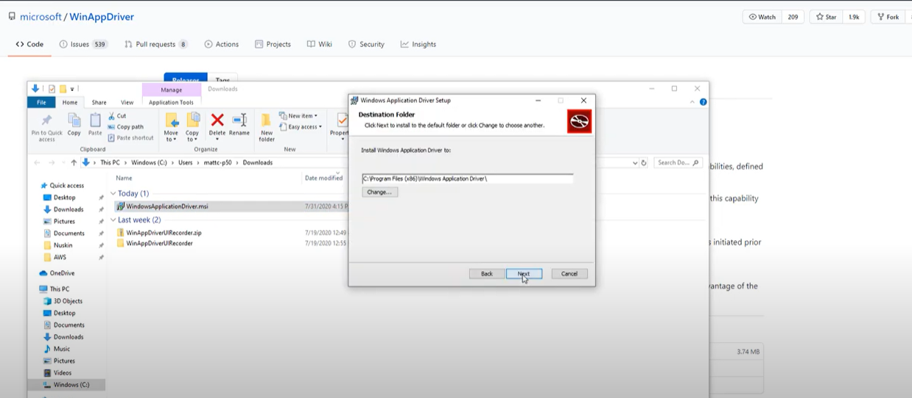

Install WinAppDriver

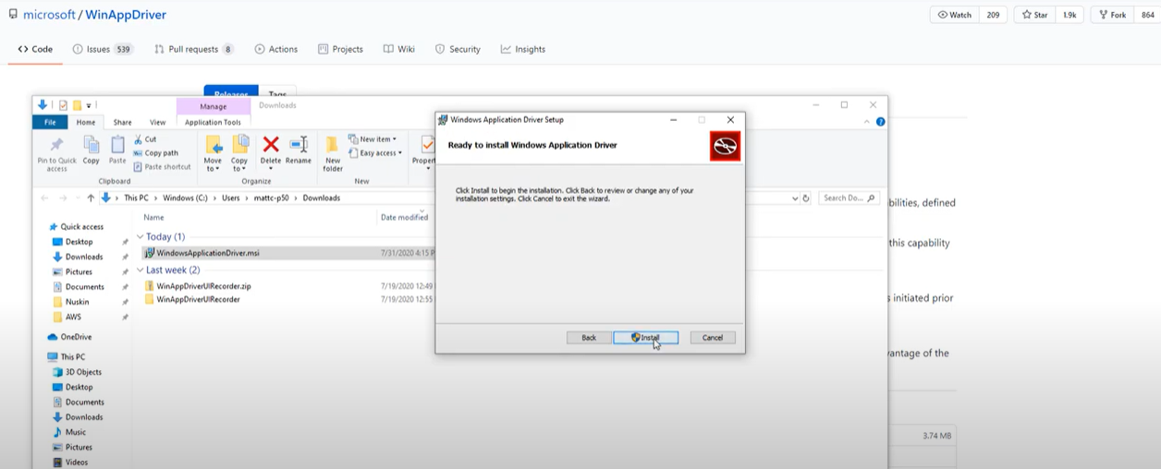

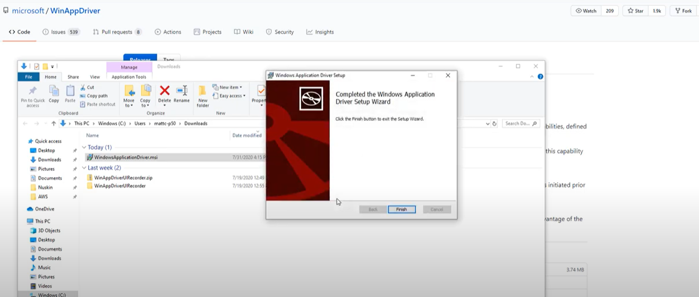

Once WinAppdriver installed in Desktop, we can access in Start menu.

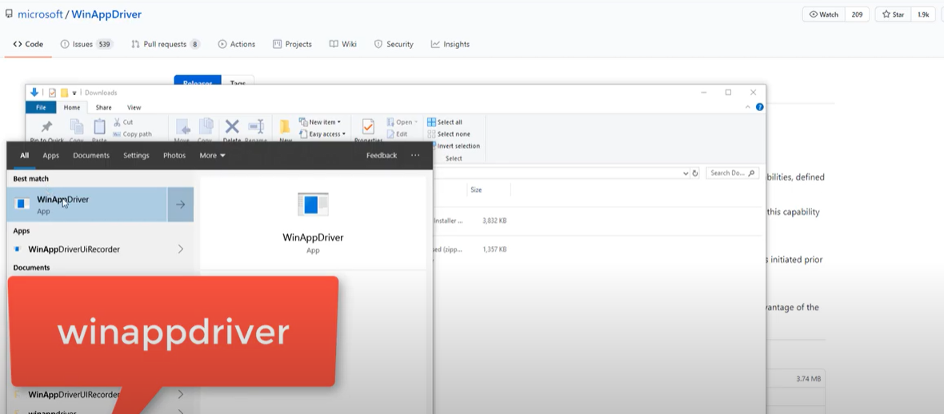

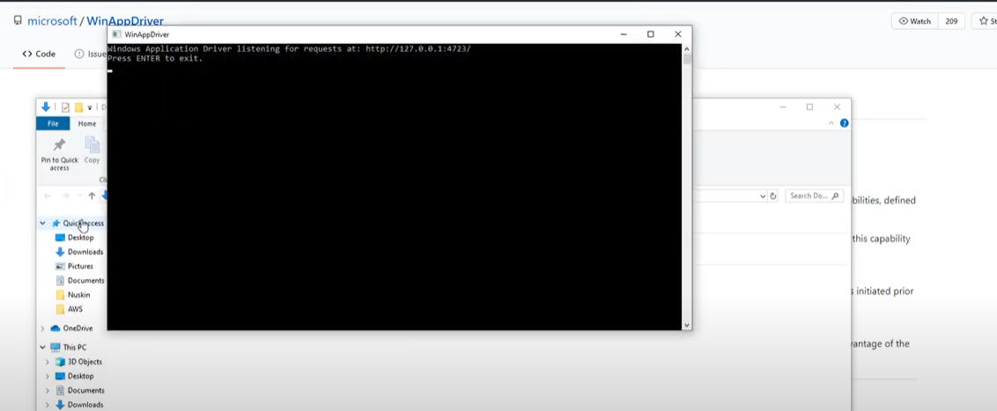

1. **WinAppDriverUIRecorder**

url : <https://github.com/microsoft/WinAppDriver/releases/tag/v1.2.1>

Download WinAppDriverUIRecorder in specified path and Extract in Local machine

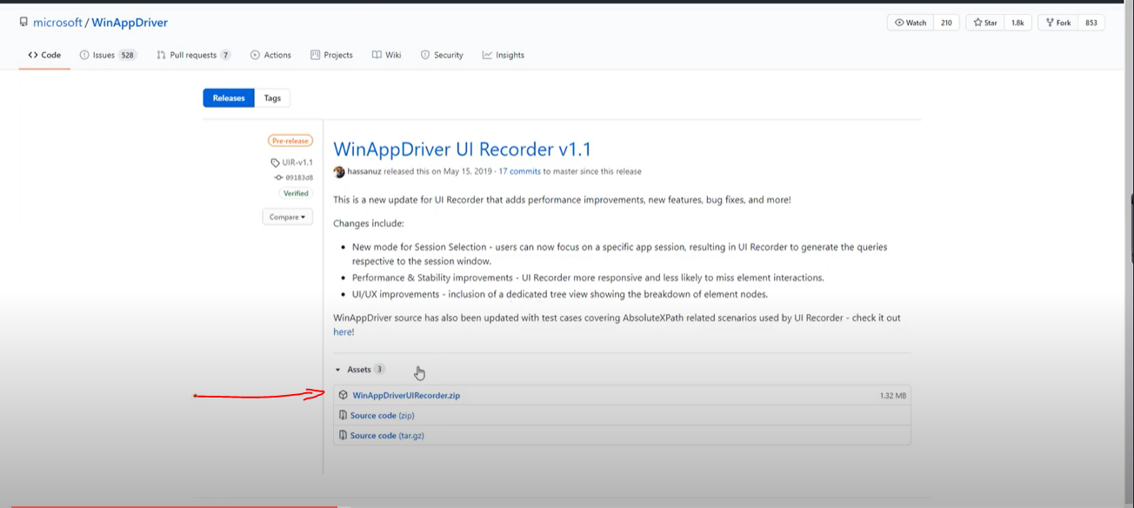

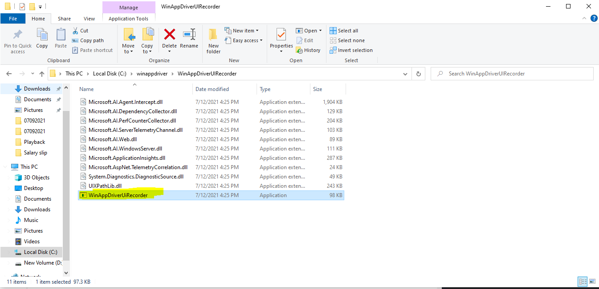

Recorder UI :

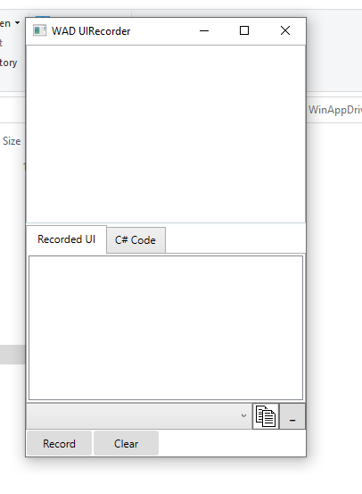

Click on record button, after all windows actions are shows in Recorded UI column

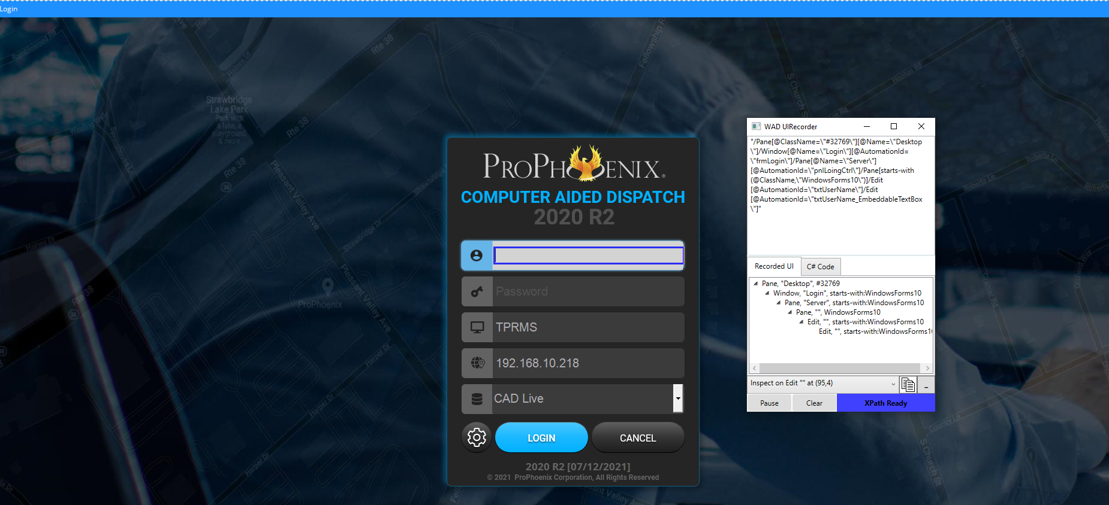

1. **FrameWork Structure:**

We followed Data driven framework with POM design pattern

Driver Class file

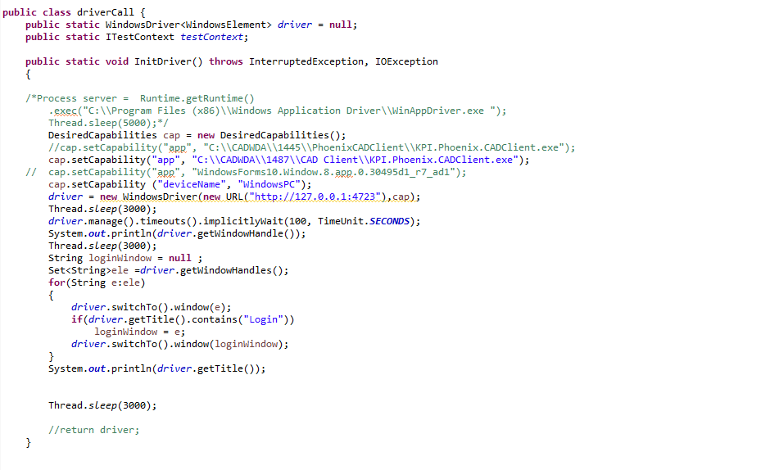

UI Class file

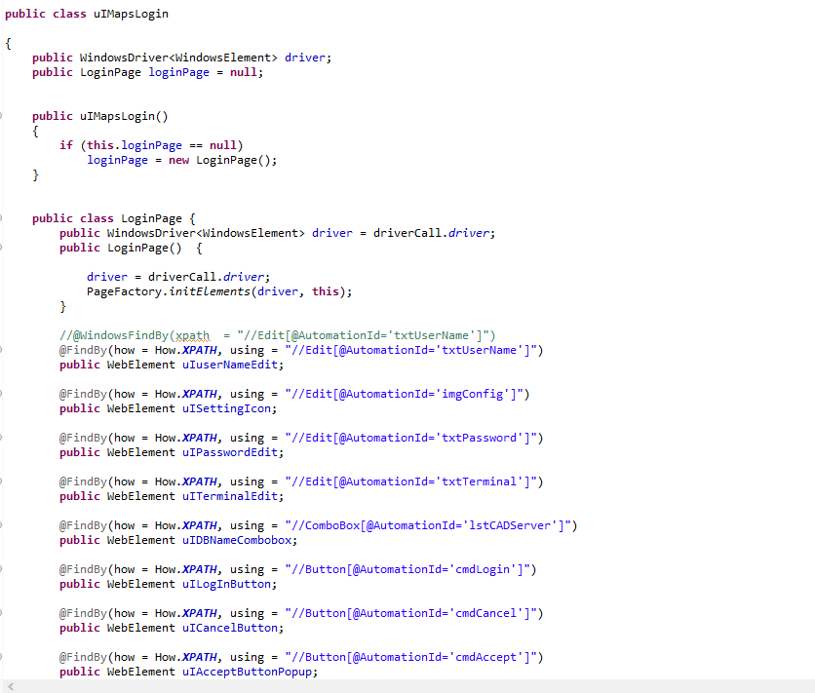

Action Class file

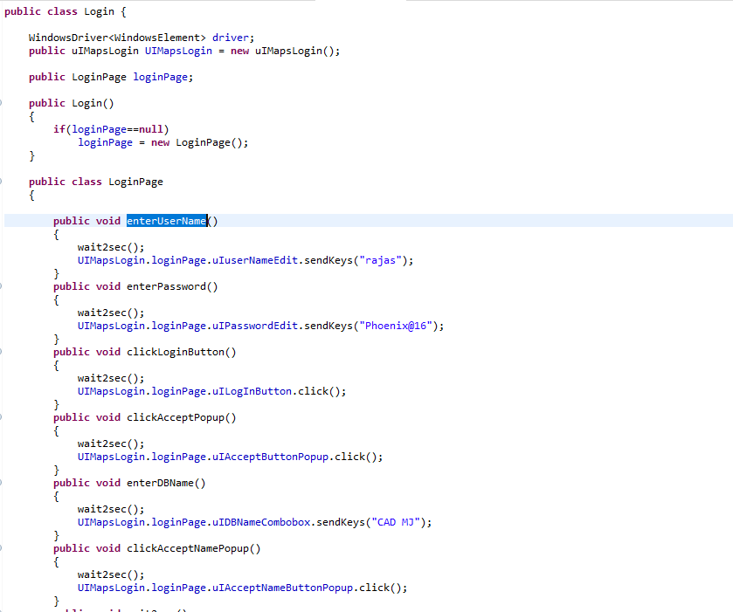

Script class file

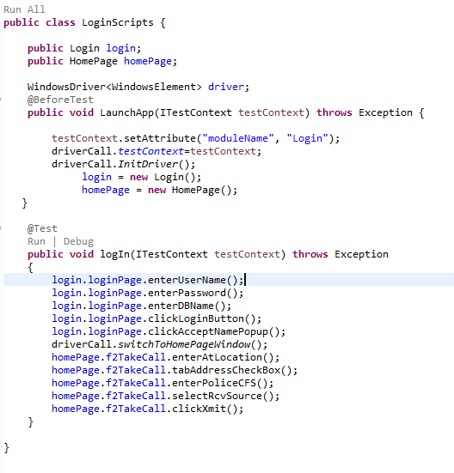

Script running report

